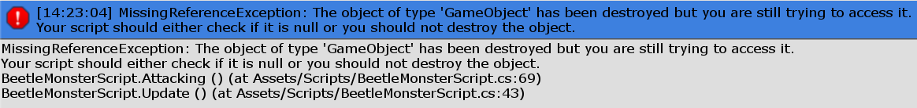

This problem occurs when Iris touch the bullet of the beetle monster before it shoot.



This one only occurs when the player trying to shoot the sample monster, since in the bullets script it looks for Enemy, would be OK when my sample monster is removed.